**REPORT – TASK 2**

**Dataset Description:**

The sales in video games have been provided in this dataset with attributes such as index, rank, game title, platform, year, genre, publisher, and country wise sales along with the review.

**Missing Values:**

The missing values were found in only two attributes ‘year’ & ‘publisher’, and they are handled.

**Visualization:**

On performing visualizations certain key facts have been found.

The plots and visualizations are listed below:

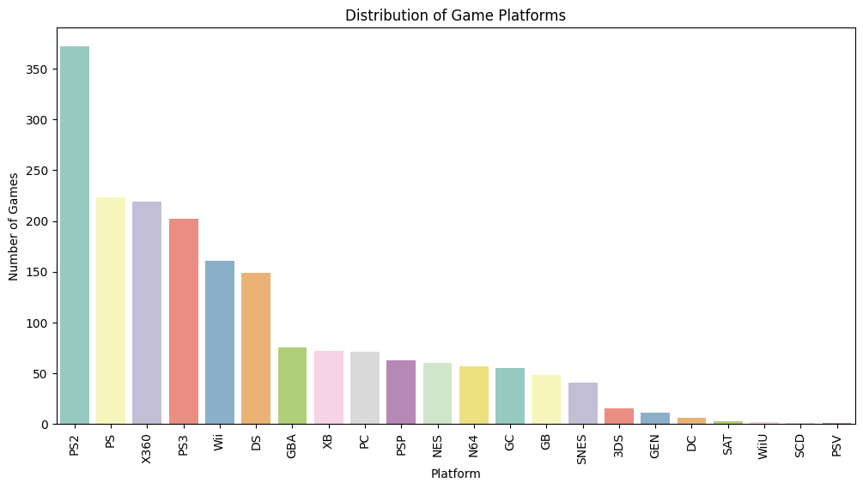

**INSIGHTS:**

* The sales of video games in North America initially experienced a peak but subsequently declined, leading to a gradual decrease in sales.
* The sports genre has the highest number of games, followed by action in the second position, and shooter in the third position.
* The analysis of game platforms reveals that the PS2 holds the top position, followed by the PS, indicating the popularity of the PlayStation series among gamers. Conversely, the PSV has emerged as the less favored platform.
* The correlation coefficient of 0.18 indicates a positive but relatively weak correlation between user reviews and global sales. This suggests that game purchases are influenced more by factors related to a game's popularity rather than less popular ones.
* Over the years, global video game sales have exhibited a remarkable increase, reaching a significant peak around the year 2010, with millions of games sold.
* On analysing the platform trends over the years, DC, 3DS, NES has huge trend setters between the year 1995 to 2010.
* The genre trends have been evolving over the years, with changes occurring consistently. However, during the period from 1995 to 2010, action-oriented genres experienced a significant and remarkable increase.
* Star wars, FIFA, Super mario are popular among the gamers.
* Adventure, action and shorts has the highest cumulative sales record.